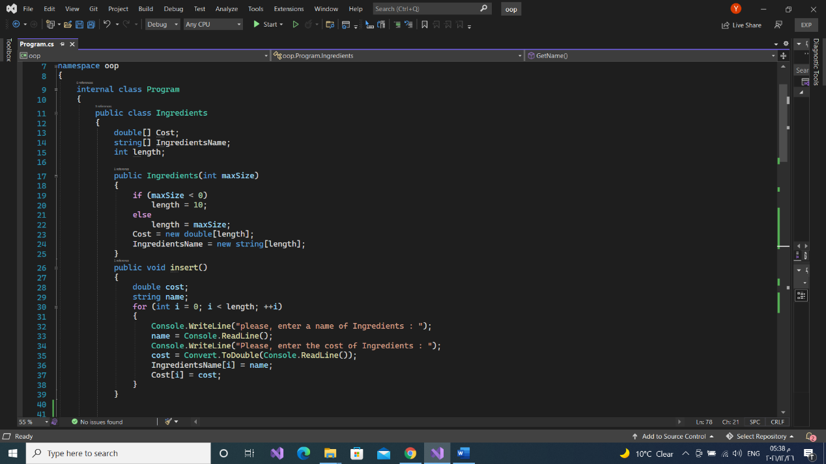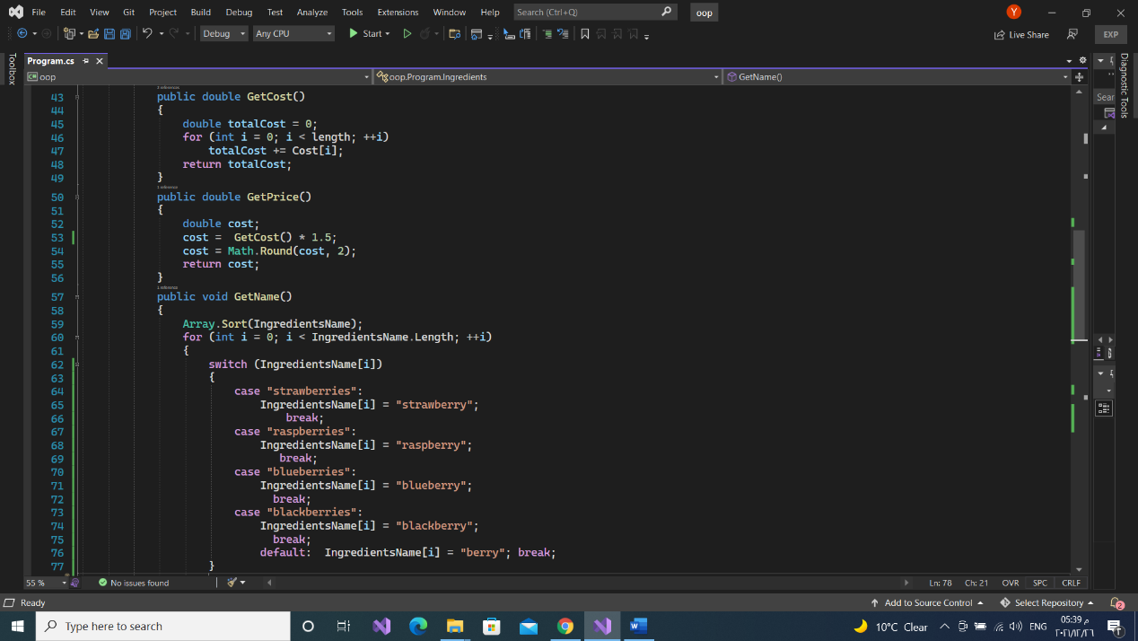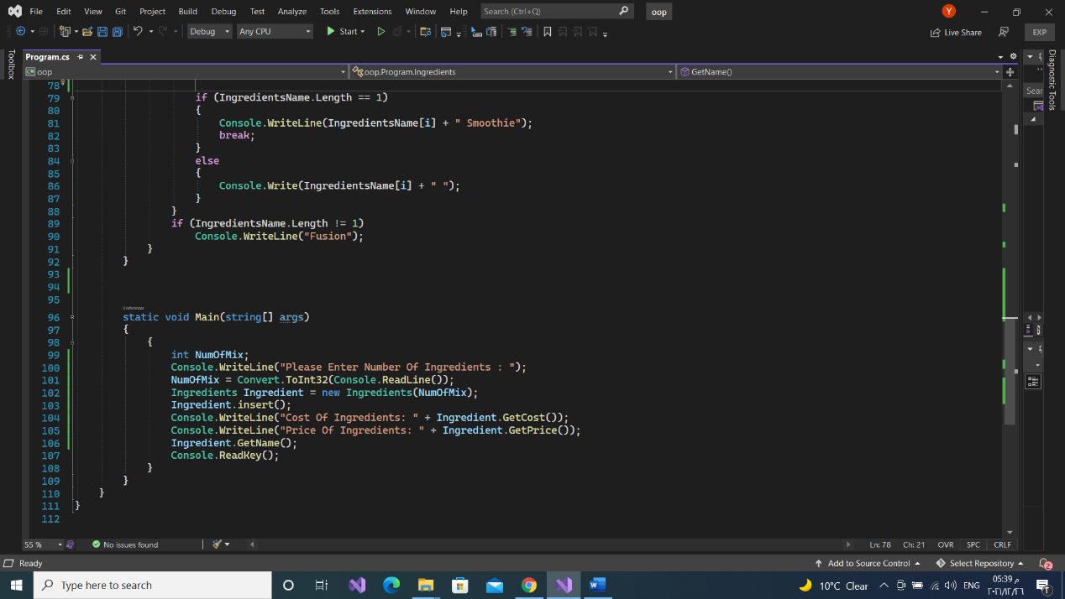

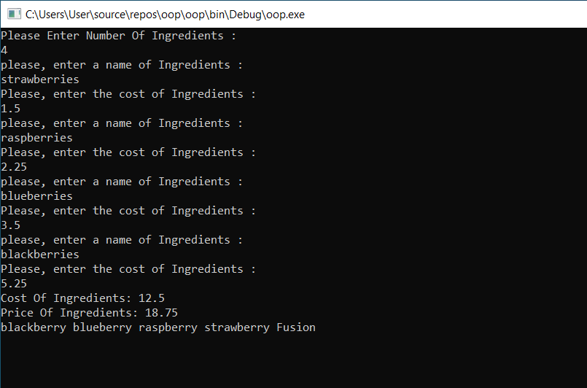

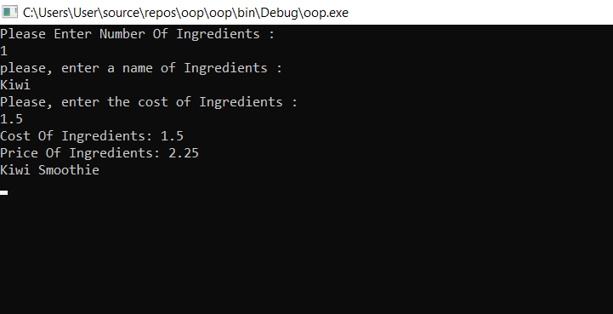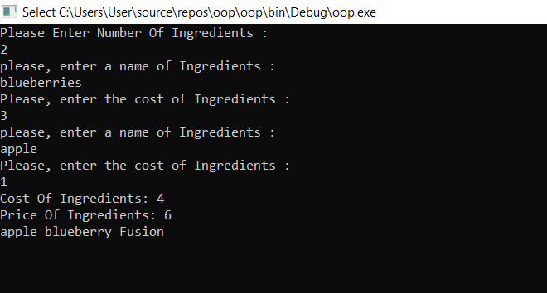

internal class Program

{

public class Ingredients

{

double[] Cost;

string[] IngredientsName;

int length;

public Ingredients(int maxSize)

{

if (maxSize < 0)

length = 10;

else

length = maxSize;

Cost = new double[length];

IngredientsName = new string[length];

}

public void insert()

{

double cost;

string name;

for (int i = 0; i < length; ++i)

{

Console.WriteLine("please, enter a name of Ingredients : ");

name = Console.ReadLine();

Console.WriteLine("Please, enter the cost of Ingredients : ");

cost = Convert.ToDouble(Console.ReadLine());

IngredientsName[i] = name;

Cost[i] = cost;

}

}

public double GetCost()

{

double totalCost = 0;

for (int i = 0; i < length; ++i)

totalCost += Cost[i];

return totalCost;

}

public double GetPrice()

{

double cost;

cost = GetCost() \* 1.5;

cost = Math.Round(cost, 2);

return cost;

}

public void GetName()

{

Array.Sort(IngredientsName);

for (int i = 0; i < IngredientsName.Length; ++i)

{

switch (IngredientsName[i])

{

case "strawberries":

IngredientsName[i] = "strawberry";

break;

case "raspberries":

IngredientsName[i] = "raspberry";

break;

case "blueberries":

IngredientsName[i] = "blueberry";

break;

case "blackberries":

IngredientsName[i] = "blackberry";

break;

}

if (IngredientsName.Length == 1)

{

Console.WriteLine(IngredientsName[i] + " Smoothie");

break;

}

else

{

Console.Write(IngredientsName[i] + " ");

}

}

if (IngredientsName.Length != 1)

Console.WriteLine("Fusion");

}

}

static void Main(string[] args)

{

{

int NumOfMix;

Console.WriteLine("Please Enter Number Of Ingredients : ");

NumOfMix = Convert.ToInt32(Console.ReadLine());

Ingredients Ingredient = new Ingredients(NumOfMix);

Ingredient.insert();

Console.WriteLine("Cost Of Ingredients: " + Ingredient.GetCost());

Console.WriteLine("Price Of Ingredients: " + Ingredient.GetPrice());

Ingredient.GetName();

Console.ReadKey();

}

}

}